**PUSH DATA ON REPOSITORY**

**Here In Git** : Repository Means Directory Means Folder

**Goto** : https://github.com/dashboard

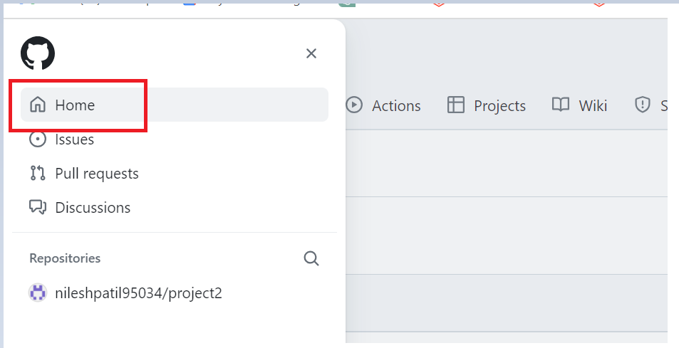

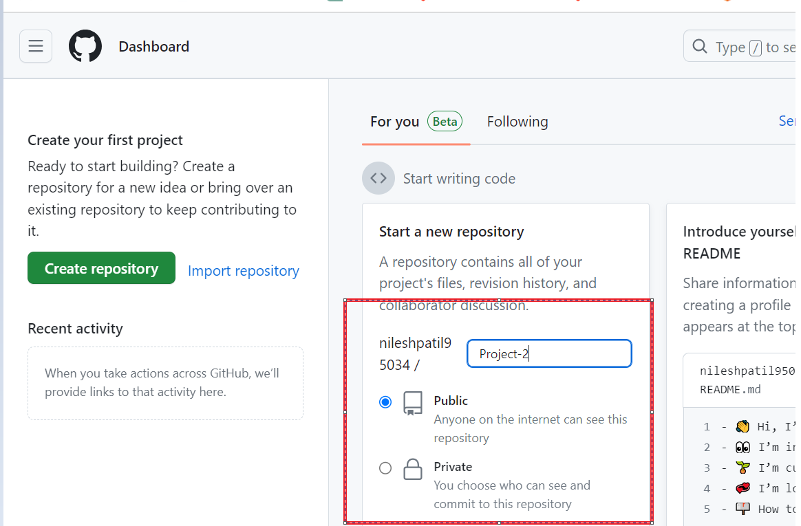

**Goto** : Local

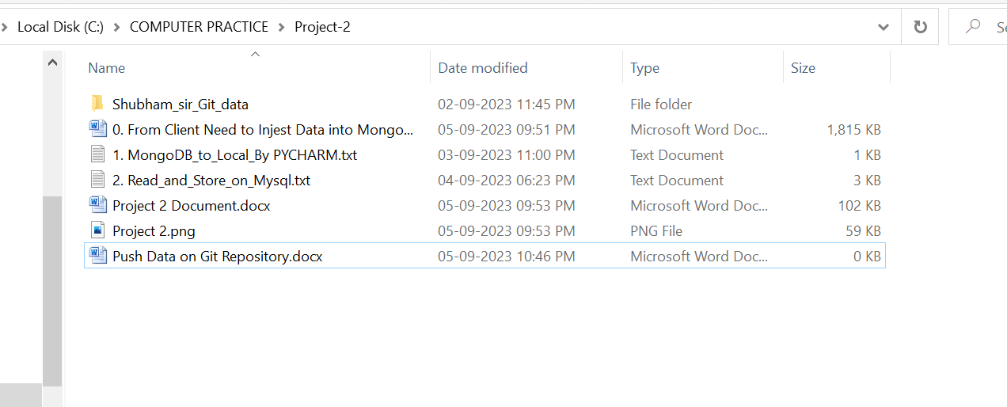

* **Now Right Click on white space**

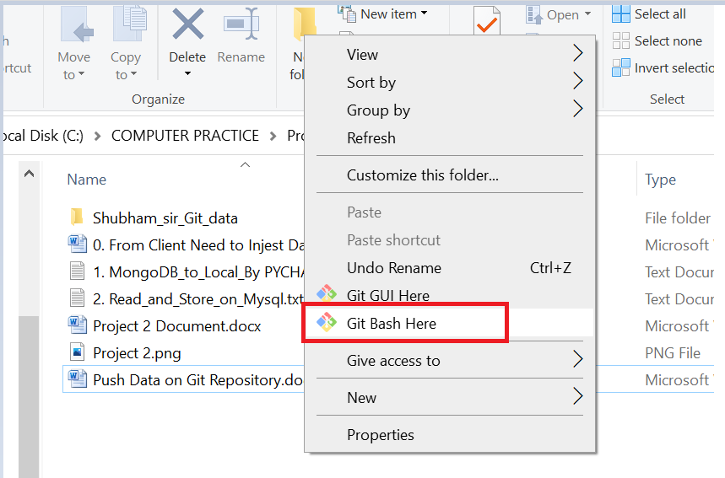

* **Open Git Bash**

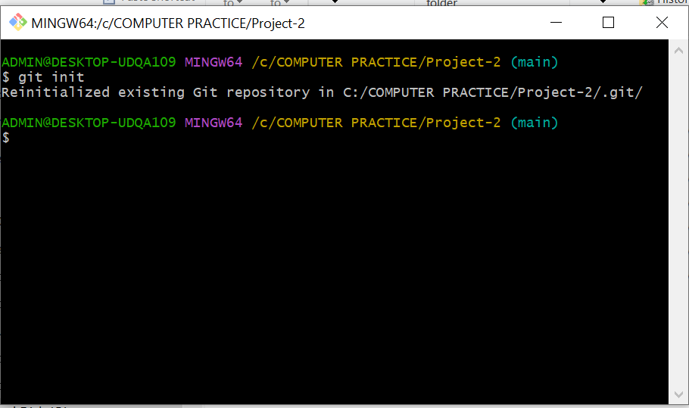

**Enter The Following Commands :**

1. git init

2. git add .

3. git commit -m "first commit"

4. git branch -M main

5. git remote add **origin** https://github.com/nileshpatil95034/Project-2.git

6. git push -u **origin** main

**Note : If there is problem in 5th command just change [origin 🡪 origin1 ] and also change in 6th line**

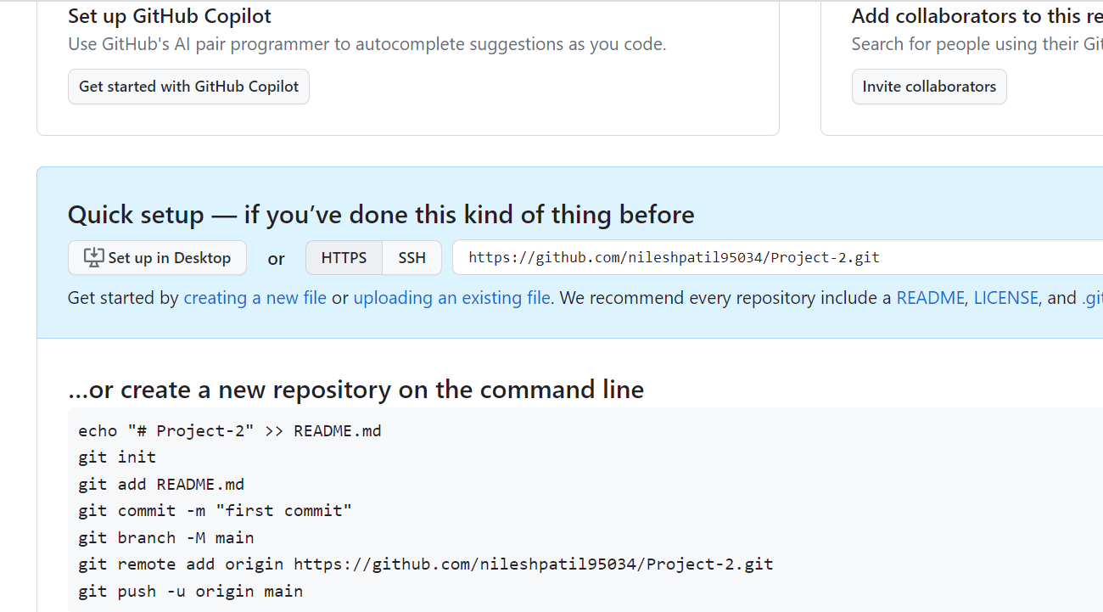

**For Check data : Goto Git Hub**

